58.10.15
To Joseph Hooker
RBG Kew, Kew correspondence, Australia, Mueller, 1858-70, f. 44a.

Melbourne bot. Garden
15 Oct. 58.
My dear Dr Hooker.
By the accident, which happened to the mail, your letter was delayed a month over the due time & I could therefore not respond to it earlier. I wished to express to you to your worthy father many thanks for all kindness evinced. Just after the bustle of our spring show of the Hort Society is over I have time yet to write a few words before the mail closes. A few days ago I got through my bookseller (not Mr Pamplin, who is far behind his enterprising colonial colleagues) the 6. fasc of F. Tasm., which is certainly a valuable continuation of a great work in a national series. Mr Archers aid in settling the [limits] of Orchideae & above all his splendid drawings (altho I have only seen the block copy) are highly creditable, altho' my own views assign other limits to the species. Thus for instance I think your whole group including the Caladenia Patersonia is comprehended under my Caladenia pulcherrima; again evidently you are at variance with Prof Lindley in some of the Diuris Pterostylis & Thelymitras &c according to his paper on my first South Austr & Tasm. orchids in the Linnaea. — My fourth No of Fragmenta, which with the 4th No of pharm journal is sent incomplete to day in the official mail, will bring several very interesting additions to your 6th fasc of Fl. Tasm.
I do not think that Hypoxis pusilla is more than a diminutive altered state of H. glabella formed in dry locality. If the pedicellate var of Trig. centrocarpum is identical with the Swan Riv. plant, Then T. trichophorum must be added as a synonym.
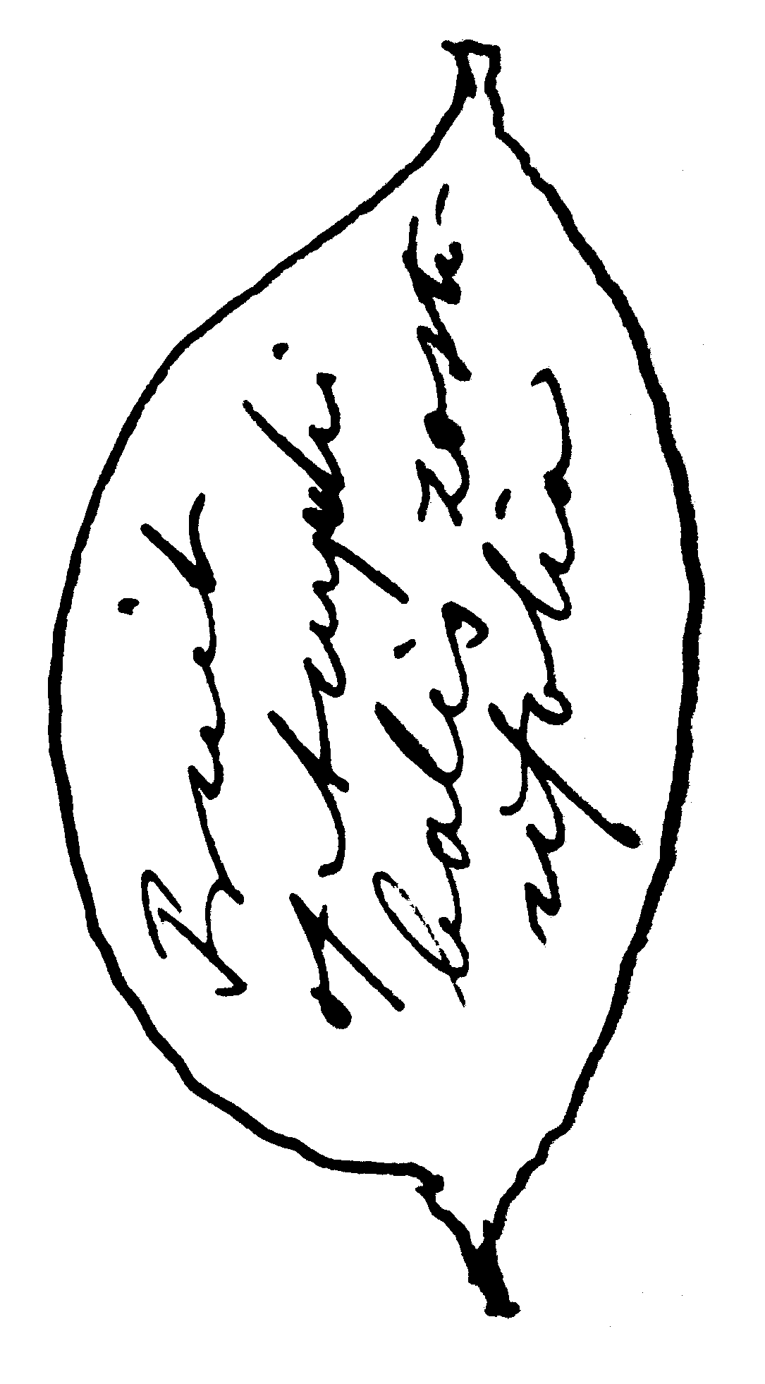
If you will think it worth while, pray refer to my description of Zannichellia Preissii. Sonder, who wrote the description for Lehmann, had no male flowers; I found & examined them & they showed 6-celled anthers invariably! It grows chiefly in brackish water on various localities from Spencers Gulf to Gipps Land. I fear that it is not to be passed as Z. palustris.
Amphibolis is an excellent genus of which I have sent in 1853 a full designation of [femal] flowers and the remarkably large fruit. Zostera uninervis Vahl grows also in Tasmania & is [wi]dely distinct in the structure of fruit from Z. marina —. It accords fully with the British plant (Z. nana Roth). — Drymophila grows in Victoria also.
Juncus capillaceus can be traced into J. prismatocarpus. I fear the Tasmanian Junci have to be reduced. Luzula Oldfieldii I cannot help regarding as L. campestris var Aphelia Gunnii = A. gracilis Sond in Linnaea 1856 p. 227. Desvauxia or Centrolepis glabra is acknowledged by Sonder as Desvauxia.

Of Juncella I have a manuscript description, but I did not like to anticipate any work of the Tasmanian Flora — I will gladly adopt the name Trithuria, because I have not been striving for personal glory but only for the truth, altho' on the other hand I think that if a humble disciple in our science as I am has sacrificed all his time & means and the energy of not returning youth to the one object alone, promoting Australian botany — some little triumph may be granted for the discoveries, which arose under so many difficulties, sacrifice of health & means and enormous labours caused by scantiness of books and collections
Trithuria is however also most closely indeed as I said in my transmitted msc. strikingly resembling Juncus capitatus Weigel! It is certainly not always submersed but grows like J. capitatus on wet places & forms beautiful red carpets or caespites like that plant when inundated, altho with receding water the plant is green! I have given the name Juncella as early as 1848 and distributed it th[us] to the herbariums of St. Petersburg, Moscow, Vienne, [Berl]in, Paris &c. The suborder which it forms combines as you very justly likewise pointed out Eriocauleae and Desvauxieae. Stuart sent it as an Eriocaulon and I weighed the affinity fully when naming it. When I called it Tasmanica, I had not visited Australia Felix, where I found the plant only 1853, but having distributed the plant so extensively (through Sonder) I did not like to change the specific name. But would under these views also not the name Dianella Tasmanica fall to the ground?
I have sent with the pharm Journal (containing some remarks on the affinity of Goodeniaceae a specimen of Goodenia amplexans trans. ph. Inst. 1857 p. 70 This very rare plant, known to me only from near St. Vincents Gulf occurs in Stuarts private herbarium from the Nile Rivulet Tasmania He thought it to be G. barbata and either did not send on this supposition the plant or it was contained in the box, lost in the wreck of the "Henry" about 10 years ago.
My garden report is just in print with a new catalogue & combined with my fourth report as Gov. Botanist, but I fear I cannot send it before next mail.
Having been so overburdened with work and in consequence suffered from illness, I have been unable yet, to attend to the excellent Ch. Darwins request to experiment on the fecundation of Goodeniaceae. I have however scarcely as many species at hand for experiment, as the British Gardens, but will never the less at an early period attend to it.
I ask one kind favor from your generosity, my dear Dr Hooker, to leave describing the Chatham Island Plants to me, as I am working on them already & shall do justice to them with your excellent fl. antarc[.] & N. Zeeland. — For bot Mag. I will send by next mail of the extraordinar Anchusa Chathamica a coloured drawing & by one of the next clippers a big root. It has the leaves almost of a Funkia!
— I feel greatly indebted to Mr Bentham and Mr Blacks editing the Acaciae & Eucalypti, and feel much honored to see the dissertations having been appreciated by the L.S. — rest assured, I shall send them many pamphlets & specimens henceforth like to Kew, but I have been absorbed in bringing the bot & zool. Garden into more creditable working order & could therefore not collect many specimens of value to Kew from remote localities. I think you have all my good plants, except those from Lake Torrens, of which I gave all the duplicates to Sonder in 1852. Many many hours I could have saved in the examination of the plants for the Garden Catalogue, had I only had a copy of Bot. Mag. & Bot. Regist.! — I think I ought to address in future Baillière. I am told he is so much more expeditious in carrying orders out than Pamplin.
The comparison of the Flora of India and North Australia becomes every day more interesting. I hear that Mr Bentham has undertaken the giants task to write an Australian Flora. I wished I could help him! A more worthy successor to the completion the prodromus flor. Nov. Holl. could not have been found, and a more honorable either. I could furnish a great deal of notes on the ranges of the species, if Mr Bentham would let me know when and how he intends to publish
With my sincerest regards for your father & yourself, I remain
your grateful Ferd. Mueller

I never received the 1 & 2 fasc. of flora Tasmanica you kindfully sent, nor any letter, which would put me on the lookout.
I am most grateful to the Linnéans for printing my report, and by circulating the spare copies I can inspire some more men with ardor for botany.
Any further identifications from Mr Blacks will be very acceptable indeed. I intend to reward him now soon by naming a good plant after him.

Acacia
Amphibolis
Anchusa Chathamica
Aphelia gracilis
Aphelia Gunnii
Caladenia Patersonia
Caladenia pulcherrima
Centrolepis glabra
Desvauxia
Desvauxieae
Dianella Tasmanica
Diuris
Drymophila
Eriocauleae
Eriocaulon
Eucalyptus
Funkia
Goodenia amplexans
Goodenia barbata
Goodeniaceae
Hypoxis glabella
Hypoxis pusilla
Juncella Tasmanica
Juncus capillaceus
Juncus capitatus
Juncus prismatocarpus
Luzula campestris
Orchideae
Pterostylis
Thelymitra
Triglochin centrocarpum
Triglochin trichophorum
Trithuria
Zannichellia palustris
Zannichellia Preissii
Zostera marina
Zostera nana
Zostera uninervis

J. Hooker to M, 22 June 1858?
J. Hooker (1860); fascicle 6, the first of vol. 2, was published on 3 May 1858 (TL2).
C. patersonii?
Lindley (1853).
The fourth part of the Fragmenta consisting of four gatherings was not published until February 1859 (B59.02.03). Dendrobium milligani, the only Tasmanian plant described in that fascicle, is in the third gathering, p. 88. B58.10.02 does not discuss Tasmanian plants in particular.
Triglochin.
M had sent Hooker a MS description of Zannichellia (not found), see M to W. Hooker, 6 April 1857 (in this edition as 57-04-06a).
Lehmann (1844-7), vol 2, p. 3, in Sonder's treatment of Typhaceae.
The text inside the marginal sketch is Fruit of Amphibolis Zosterifolia. 58-10-15_image01.jpg
Sonder (1856a).
Juncella tasmanica (B54.10.01).
B57.09.04.
See C. Stuart to M, 8 January 1849.
B58.11.02.
No evidence of a response by M to Darwin has been found. See Lucas (2010).
J. Hooker (1844-7), J. Hooker (1853-5).
Almost certainly Myosotidium nobile: see B64.10.02, pp. 32-34.
Alan Black.
B58.11.01, B59.12.01.
Hippolyte Baillière.
See G. Bentham to M, 23 August 1858.
R. Brown (1810).
B58.05.01.
See J. Hooker to M, 22 June 1858 for a comment on Black's role. M described Milletia blackii for Alan Black (B61.02.02).

